1st SUNDAY OF ADVENT
SEASON OF HOPE

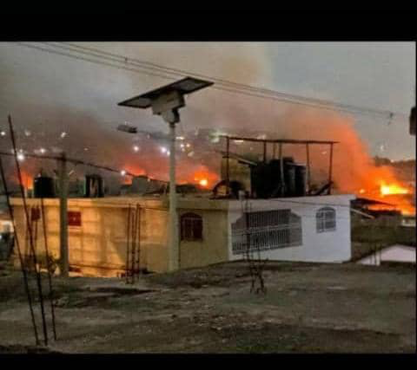
We begin the magnificent feast of Advent on the 1st of December this year. It is the first Sunday of Advent. It is also the beginning of the Dominican Month of Peace 2024 which we dedicate to Haiti where twenty Dominicans are ministering in harsh and dangerous conditions.
The readings today invite us into reflection on the virtues of HOPE and Justice.

This photo was taken on October 28,2024 in Haiti
in Delmas 24 area, Courtesy of Gerard Straub

Jeremiah recalls the promise God made to the house of Israel and Judah. He promised to raise up David to do what is right and just in the land as well as the possibility of dwelling in safety, security and justice.

In response Judah gives God the name of Justice.

Justice the name of God is sweet to the ears of the people of Haiti who wait in HOPE for Justice. For more than two and half years the people of Haiti have been suffering and dying at the hands of teenagers. Twelve, thirteen, fourteen-year-old children carrying guns, threatening young and old alike. The people have also been deprived of food, shelter, opportunity to go to school as well as access to health care because it is too risky to go out of their homes, walk to school or try and find food because of the gangs.

It is truly a hell on earth. Here at the United Nations, we receive daily reports on the suffering of the people of Haiti. They live with heartbreak and unbearable fear, and unspeakable violence against women and food insecurity. There is truly no serenity in Haiti.

An example of what is happening is the massacre of October 2-3, 2024 that took place in the section of Saint-Marc, in Pont-Sondé. At least 70 (seventy) people were killed including babies, children, women, the elderly and others who were injured by gunfire. Hundreds of families fled the violence of the “gran grif” gang. As the massacre was taking place the people walked for hours and passed by numerous corpses in hopes of finding shelter and safety.

In spite of the new Presidential Transition Council (CPT) formed five months ago they still have not taken any measures to retake control of the gang-occupied areas, let alone disarm them, arrest them or bring them to justice.

Psalm 25, today’s responsorial psalm is an applicable to the Haitian people in their time of need.
Make known your ways to us O God,
We wait for your all day
Guide us to Justice
To You O God we lift up our soul.

As Dominicans we stand in solidarity with our brothers and sisters who live in Haiti and are in this incredibly precarious position. May they feel our commitment to pray and work for peace. May justice reign and Peace Prevail in Haiti.

Song:
If Not Now -https://youtu.be/7bY585-fzSs?si=HHk2qSnRAqDBodie
Carrie Newcomer Words and Music Used with permission.

Chorus
If not now, me when (2x)
We may never see this moment
Or place in time again
If not now, if not now, tell me when?

I see sorrow and trouble in this land (2x)
Although there will be struggle
We’ll make the change we can
If not now, if not now, tell me when?

Chorus:

I may never see the promised land (2x)
And yet we’ll take the journey
We’ll walk it hand in hand
If not now, if not now, tell me when?

Chorus

We‘ll work until it’s done
Every daughter every son
Every soul that’s ever longed for something better
Something brighter
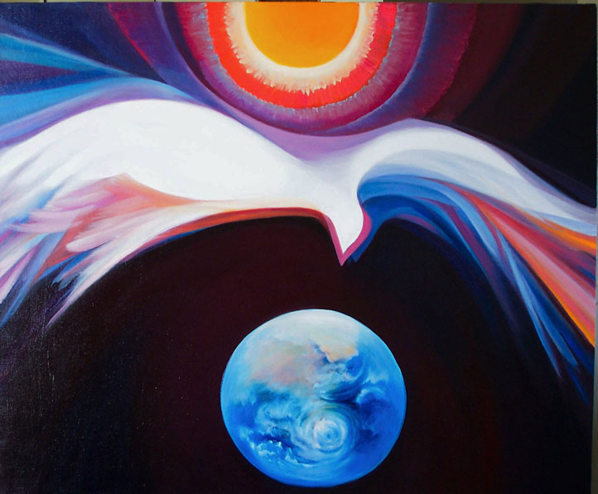
It will take a change of heart for this to
mend (2x)
But miracles do happen every shining now and then
If not now, if not now, tell me when?

Chorus

And miracles do happen every shining now and then
If not now, if not now, tell me when? (2x)

www.ministryoftheheart.org
used with permission

Sr. Durstyne Farnan, OP

