The Center at Mariandale is proud to welcome
Sister Norma Pimentel, MJ
Executive Director, Catholic Charities of the Rio Grande Valley
Who will speak on:

Welcoming our Refugee Brothers and sisters
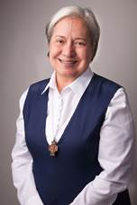  Sister Norma Pimentel, MJ |  |  | For the past three decades, Sister Norma has been supporting more than 100,000 migrants seeking refuge in the U.S. along Texas' border with Mexico with emergency food, shelter, housing assistance, clinical counseling and pregnancy care.  She has been personally recognized by Pope Francis and is a recipient of the University of Notre Dame’s prestigious Laetare Medal. In 2020, Sr. Norma was recognized by Time magazine as one of the 100 most influential people in the world.
Wednesday, September 14, 2022, 7pm
The Chapel at the Center at Mariandale
299 N. Highland Avenue, Ossining, NY 10562
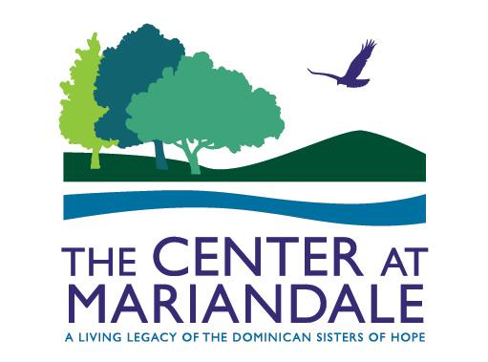 |  | The Center at Mariandale  914-941-4455 |  info@mariandale.org  www.mariandale.org

The Center at Mariandale
914-941-4455 |
info@mariandale.org |
www.mariandale.org

