Immigration Facts vs Fiction
All but one of these came from the George W. Bush Institute. I added other resources to back up their facts.
(https://www.bushcenter.org/publications/resources-reports/reports/immigration.html?gclid=EAIaIQobChMIx9_GqaqI3AIVSdbACh1MGgaJEAAYASAAEgJsk_D_BwE)

Fiction: Immigrants are taking over
Fact: Immigrants actually only account for 13.5% of the total U.S. population, which is in line with historical norms. More than 43.7 million immigrants resided in the United States in 2016, accounting for 13.5 percent of the total U.S. population of 323.1 million, according to American Community Survey (ACS) data. Between 2015 and 2016, the foreign-born population increased by about 449,000, or 1 percent, a rate slower than the 2.1 percent growth experienced between 2014 and 2015.
Immigrants and their U.S.-born children now number approximately 86.4 million people, or 27 percent of the overall U.S. population, according to the 2017 Current Population Survey (CPS).
https://www.migrationpolicy.org/article/frequently-requested-statistics-immigrants-and-immigration-united-states

Fiction: Immigrants are all Mexican.
Fact: Since Mexico is so close to the US, it’s not surprising that many immigrants come from Mexico. However, 30% of immigrants come from Asia, and currently more are coming from China than Mexico. In the US, 11.5 million immigrants living were from Mexico; 6% from China, 6% from India, 5% from the Philippines and 3% from El Salvador. Immigrants were born from South and East Asia combined accounted for 27% of all immigrants equal to Mexico. 14% from Europe/Canada, 10% from the Caribbean, 8% from Central America, 7% from South America, 4% from the Middle East and 4% from sub-Saharan Africa.
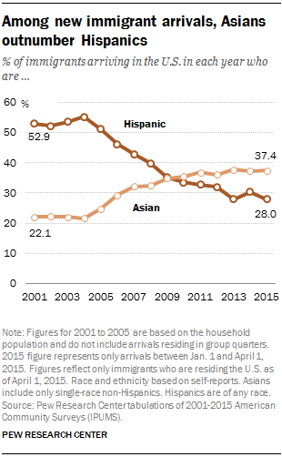
About 1 million immigrants arrive in the U.S. each year. In 2015, the top country of origin was India with 110,000 new immigrants.
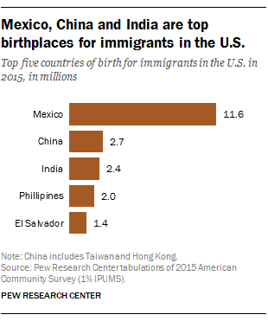

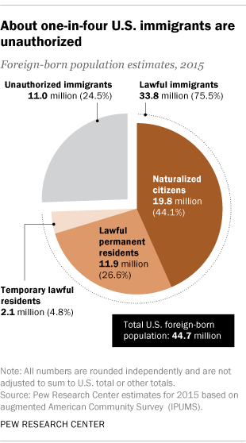
Fiction: Immigrants are coming here illegally.
Fact: Only 25% of immigrants are undocumented. 44% of foreign-born population are naturalized citizens and 26.6% are lawful permanent residents.

Fiction: Immigrants don’t work.
Fact: 72.5% of immigrants believe hard work is how you succeed in America and are responsible for half of the total U.S. labor force growth over the last decade. In 2017, the unemployment rate for immigrants was 4.1%.
https://www.bls.gov/news.release/pdf/forbrn.pdf

Fiction: Immigrants don’t help the economy.
Fact: There are many ways to help the economy. Immigrant-owned businesses with employees have an average of 11 employees. Immigrants, including undocumented immigrants, pay taxes. These tax contributions add up. Immigrant-led households across the country collectively paid $223.6 billion in federal taxes and $104.6 billion in combined states and local taxes in 2014, the most recent year for which Census data is available. (American Immigration Council). The Institute of Taxation and Economic Policy suggested that half of undocumented worked in the US file income tax returns. 4.4 million income tax returns were paid by workers without Social Security numbers. They pain 23.6 billion in income taxes. (VOX)

Fiction: Immigrants take American jobs
Fact: 7.6% of immigrants were self-employed compared to 5.6% of native-born Americans and they founded more than 40% of Fortune 500 companies. Research reported in the New York Times suggests that “over the long term, immigration had no negative effects on the ways and jobs of native-born workers.”
https://www.nytimes.com/2016/09/22/us/immigrants-arent-taking-americans-jobs-new-study-finds.html

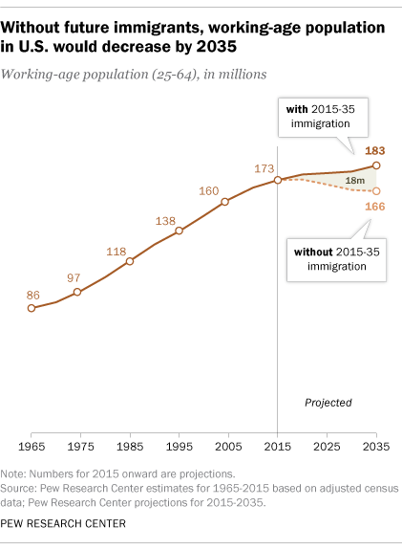
Fiction: Immigrants are too young or old to work.
Fact: More than 70% of immigrants are between the ages of 25-64 compared to less than 50% of native-born Americans. By 2035, the working age of immigrants will increase by 18 million. According to Pew Research, most of the loss of workforce caused by the baby boomers will be offset by U.S.-born adults with immigrant parents and the arrival of future immigrants. Only 15% of Immigrants are ages 65 or older (the same as US born.)
https://www.migrationpolicy.org/article/frequently-requested-statistics-immigrants-and-immigration-united-states

http://www.pewresearch.org/fact-tank/2017/03/08/immigration-projected-to-drive-growth-in-u-s-working-age-population-through-at-least-2035/

Fiction: Immigrants take advantage of welfare
Fact: 62.2% of immigrants aged 16 and older were employed compared to 58.1% of native-born Americans. According to the CATO Institute, “Overall, immigrants are less likely to consume welfare benefits and, when they do, they generally consume a lower dollar value of benefits than native-born Americans.” https://www.cato.org/publications/immigration-research-policy-brief/immigration-welfare-state-immigrant-native-use-rates

Fiction: Immigrants aren’t educated
Fact: Recent immigrants are more likely to have college degrees than native-born Americans and are more likely to have advanced degrees. In 2016, 30% of immigrants ages 25 or older had a bachelor’s degree or higher. College educated immigrants were 47%. 29% of immigrant adults did not have a high school diploma or GED certificate.
https://www.migrationpolicy.org/article/frequently-requested-statistics-immigrants-and-immigration-united-states

Fiction: Immigrants increase the crime rate.
Fact: Sociologist Robert J. Sampson, in an American Immigration Council, 2015 Report, stated “cities of concentrated immigration are some of the safest places around.” Immigrants as a group tend to be highly motivated, goal-driven individuals who have little to gain by breaking the law. Sampson and colleagues also find that immigrant communities are insulated from crime because they tend to display “social cohesion among neighbors combined with their willingness to intervene on behalf of the common good.”
https://www.americanimmigrationcouncil.org/sites/default/files/research/the_criminalization_of_immigration_in_the_united_states.pdf

